**Part b)**

In this section the three liquidity factors and the market excess returns are regressed against the excess returns of the portfolios. The two steps Fama-Macbeth method was used to test this model.

The values of beta1, the exposure of the portfolios to factor1, is shown on figure1. Beta1 of the 25 portfolios range from 0.89 to 1.36. This may be problematic when calculating the values of the risk premium for the market excess returns. A low variation in the sample may cause estimation errors. However, the Betas for factor 2,3 and 4 have more variability.

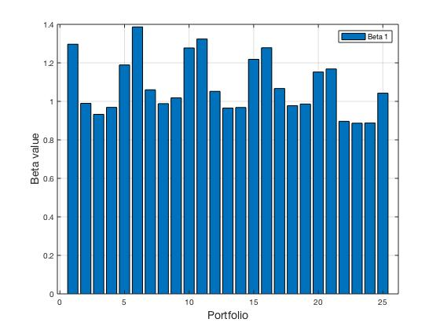

The estimates of the risk premiums (gammas) is obtained my regressing the estimates of the betas of the excess returns of the portfolios. The values of the gammas for the factors:

|  |  |  |  |  |  |
| --- | --- | --- | --- | --- | --- |
|  | gamma0 | gamma1 | gamma2 | gamma3 | gamma4 |
| Extended facotr model | 0.2181  (0.6054) | 0.3069  (0.9631) | 0.0720  (4.6196) | 0.0256  (2.4805) | -0.0549  (-6.0122) |

Gamma0 has a value of 0.2181 and a t-value of 0.6054. With a 5% significance level Gamma0 is insignificant. Gamma1 has a value of 0.3069 and a t-value of 0.9631. With a 5% significance level Gamma1 is insignificant. By looking at Gamma1 over time, it appears to be positive in some cases and negative in others. This may suggest that investors are sometimes compensated for added risk and penalized in other. The fact that Gamma1 takes a negative value can be explained by the fact that when the market returns are positive, portfolios with betas higher than 1 will may have negative returns as they are more volatile. (combined with the fact that the betas have low variability).

The estimates for gamma1 is different from part a) as expected. The addition of the factors explains some of the variation of the returns. However, the liquidity factors are correlated, and this may introduce multi-collinearity. This may affect the estimate of the gammas in the first model.

*Because of the averaging of the gammas the residuals will have heteroscedasticity and autocorrelation. To correct this the Newey-West method was used to obtain the t-statistic.

*The fact that liquidity factors are correlated with the excess market returns explains the difference between the models in part a) and b). When the market is preforming badly the liquidity available will decline significantly (reference1).

Next, we estimate each liquidity factor in a separate regression as to avoid multi-collinearity. **( To be continued…).**

|  |  |  |  |
| --- | --- | --- | --- |
|  | gamma0 | gamma1 | gamma2 |
| aggregate liquidity | 0.866  (1.363) | -0.397  (-0.628) | 0.061  (2.515) |

**Part c)**

In this section the CAPM and the extended factor model are re-estimated using data from the period September 2008 to September 2018. The results of the re-estimates are represented in table(x).

|  |  |  |  |
| --- | --- | --- | --- |
|  | gamma0 | gamma1 | gamma2 |
| capm | 0.926  (4.33) | -0.004  (-0.023) |  |
| Factor 1 | 1.28  (6.16) | -0.345  (-1.94) | -0.014  (-2.81) |
| factor 2 | 1.13  (5.89) | -0.24  (-1.41) | -0.024  (-2.82) |
| factor 3 | 0.95  (4.73) | -0.013  (-0.07) | -0.002  (-0.005) |

For CAPM the intercept value is 0.926 and it is significant with a t-value of 4.33. While gamma1 has a value of -0.004 and it is not significant. However, in the in-sample model of CAMP the estimate of the intercept is 1.35 with a t-value of 2.33. While, the gamma1 is -0.76 and it is insignificant with a t-value of -1.32. The out-of-sample CAPM has a lower intercept than the in-sample. However, the difference is not of a significant nature.

For the extended factor model, we ran three regressions for each factor. In the out-of-sample data all of the three liquidity factors seem to have a negative gamma value. However, the traded liquidity factor gamma is not significant. On the other hand, the in-sample three factor model the gamma values for the aggregate liquidity factor is positive.

The aggregate liquidity factor is significant in both samples. While the innovation in liquidity is significant only in the in-sample. For the traded liquidity factor, it is significant in the out-of-sample, but not in the in-sample.

The intercept in the aggregate liquidity and traded liquidity have decrease from 1.28 and 0.95 to 0.86 and 0.88 respectively. However, both intercepts are not significant in the out-of-sample.

The fact that all of the models do not give as a significant value for gamma1 has to do with the large variance of gamma1. As shown from the graph of gamma1 overtime. Also, from this graph we can see that there was a high fluctuation in gamma1 in 2009. Which may correspond to the financial crisis.

The out-of-sample extended factor models implies that the liquidity factor explain the changes in the excess returns of the portfolios. This shows that liquidity factor influences the asset pricing. However, all of the liquidity factors gammas are negative, which implies that a higher exposure to liquidity risk leads to lower returns. This may be explained by the downward spike in the gammas of all the factor in the out-of-sample data in 2009. This may be attributed to the Financial crisis. Where portfolios with higher sensitivity to liquidity suffered lower returns as a result of the credit crunch. Also, the intercepts obtain from the regression reported a downward spike corresponding to the same period. This reinforces the fact that the models do not capture all the movement in the excess returns of the portfolios.

Generally speaking, the out-of-sample results do not seem to deviate much from the in-sample ones. We conclude that the liquidity factors do explain partially the movement in the excess returns of the portfolios.

**

(The theory of asset pricing tells us that the gamma1 must be positive in expectation only. The fact that gamma1 take both positive and negative vales is driven by the volatility of the portfolios whose betas are greater than 1. Portfolios whose betas are greater than 1 exhibit higher fluctuations are their returns. Hence, in a month were the riskier portfolios have lower returns than less risky portfolios, the gamma1 obtain in this month will be negative. This can be seen from the graph of gamma1’s over time. These fluctuations make it difficult to pin down the relationship between the betas and excess return of the portfolios.) (Low momentum = high beta).

Hameed, A., Kang, W. and Viswanathan, S., 2010. Stock market declines and liquidity. *The Journal of Finance*, *65*(1), pp.257-293.